**Physical Inventory**

This is done to adjust the system inventory with the physical stock.

In terms of Inventory Management, it is called Physical Inventory

In terms of warehouse Management, it is called as Cycle Inventory

MI01 M102 MI03

Tcode to print is MI21

SAP - Process:

**Step 1 - Create a PI Document – MI01**

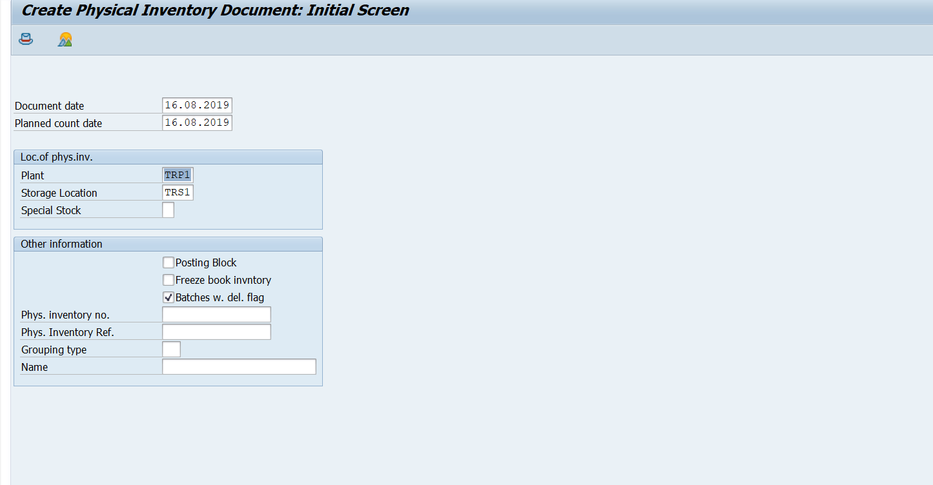

Ways to do PI - >>

1) Posting Block – Where the GR/GI transactions are not permitted until PI is Posted.

2) Freeze Book Inventory – Where GR/GI transactions are permitted but are stored in a separate temporary table until the PI is posted.

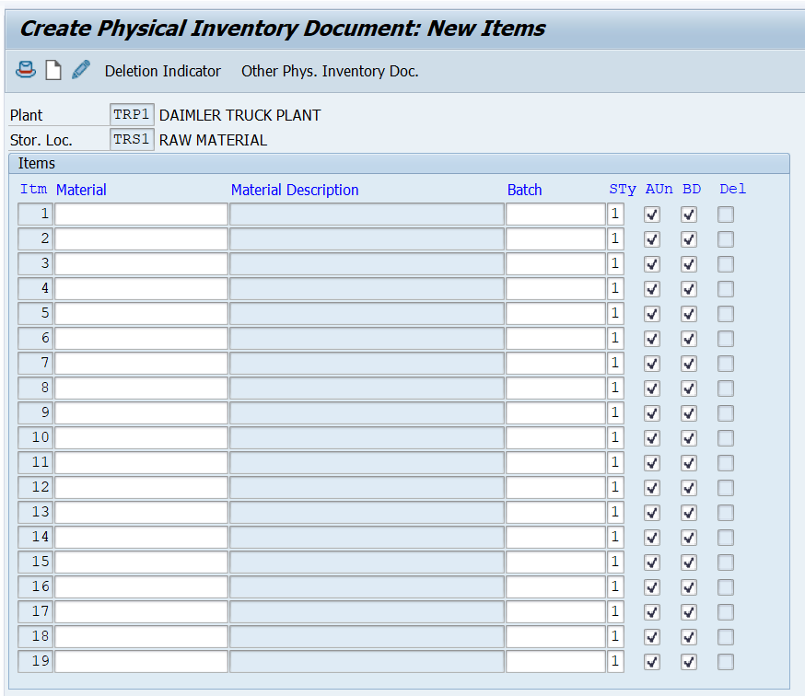

The Material and Batch should be entered for the PI to be performed – Also the Storage type should be mentioned – Whether it is a warehouse, QI, Blocked

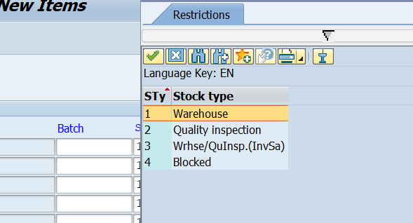

Save and PI document is posted and printed document looks as below

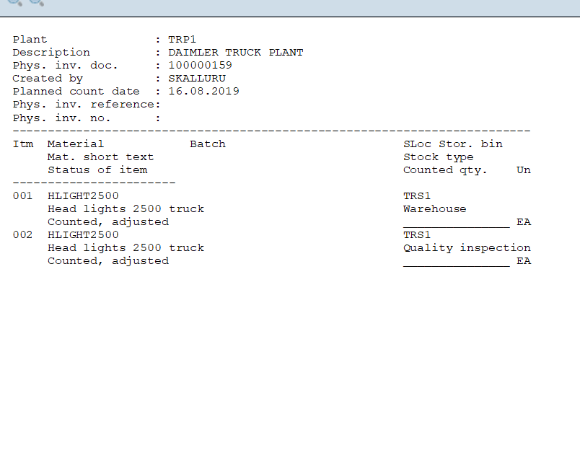

**Step 2**

**Inventory Count – MI04**

**MI04 MI05 MI06**

Enter the physical count from the document against the PI document .This is the stock count performed physically by operator.

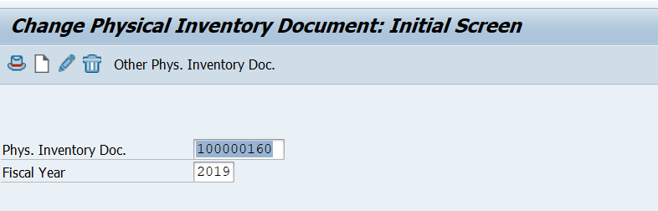

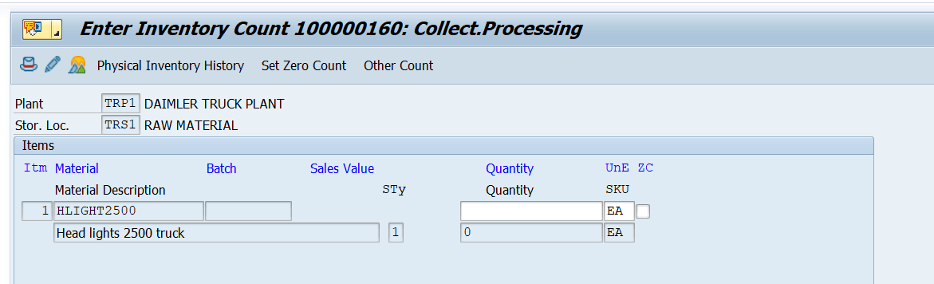

SAVE – PI document

**STEP 3 - Difference list - MI20**

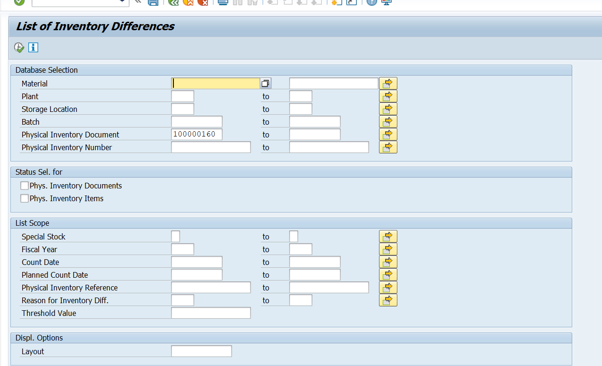

Enter the PI document number and execute

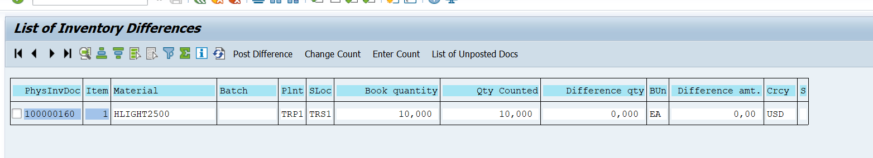

Select the PI document and Post difference – the diff value and amount are seen in this screen.

If the difference is not correct i.e. there is a huge difference in the book and physical qty then recount can be done again to take a decision – MI11

Which can be posted again in the difference -MI20

Posting can be done in MI20 – Difference List or directly in Post MI07